1. Introduction
This project, “Implement Client Script & UI Policy (Incident)”, focuses on improving data accuracy and consistency in ServiceNow Incident records. The project demonstrates how UI Policies, UI Policy Actions, and Client Scripts can be used to dynamically control form behavior, enforce required information, automatically populate values, and restrict certain user actions.
The implementation is designed to reduce incomplete or inconsistent Incident submissions and improve the quality of Incident Management data.
2. Problem Statement
Incident records require accurate and consistent information for effective Incident Management. Manual validation can result in incomplete, inconsistent, or incorrect data being submitted.
These issues can affect reporting, SLA compliance, and overall service quality. Therefore, client-side controls are required to guide users and enforce appropriate data-entry rules while working with Incident records.
3. Project Objective
The main objective of this project is to demonstrate the use of ServiceNow UI Policies and Client Scripts to enforce data integrity on Incident records.
The project implements dynamic form controls that:
- Make required fields mandatory under specific conditions.
- Automatically populate appropriate field values.
- Control field behavior dynamically.
- Prevent submission when required conditions are not satisfied.
- Restrict inappropriate updates through list editing.
- Improve the accuracy and consistency of Incident records.
4. System Requirements
4.1 Platform
- ServiceNow
- Incident Management module
- Incident table
4.2 Functional Requirements
The system should:
- Detect when an Incident has Impact = 1 – High.
- Make the required assignment information mandatory under the specified condition.
- Control the Urgency field when the Incident has high impact.
- Automatically set Urgency to High when Impact is changed to High.
- Prevent an Incident from being submitted when the required assignment information is missing.
- Prevent State from being changed through list editing.
- Allow State changes through the normal Incident form.
These requirements are implemented using UI Policies, UI Policy Actions, and Client Scripts as specified in the project tasks.
4.3 Technical Components
Component | Purpose
UI Policy | Controls form behavior based on conditions
UI Policy Action | Controls individual field properties
onChange Client Script | Automatically updates Urgency
onSubmit Client Script | Validates required assignment information
onCellEdit Client Script | Blocks State changes through list editing
Incident Table | Main table used for the project

5. System Design & Workflow
The project follows a condition-based workflow in the ServiceNow Incident form.
Basic workflow:
User Opens Incident
↓
User Enters / Changes Impact
↓
Is Impact = High?
↓
YES
↓
Assignment Information → Mandatory
↓
Urgency → Automatically Set to High
↓
Urgency → Read Only
↓
User Attempts to Submit
↓
Is Assigned To Available?
↙ ↘
NO YES
↓ ↓
Show Error Save Incident
↓ ↓
Stop Submit Incident Updated

For list editing:
Incident List
↓
User Attempts to Edit State
↓
onCellEdit Client Script
↓
Alert Message
↓
State Change Blocked
Figure 1: System Workflow for Incident Client-Side Controls

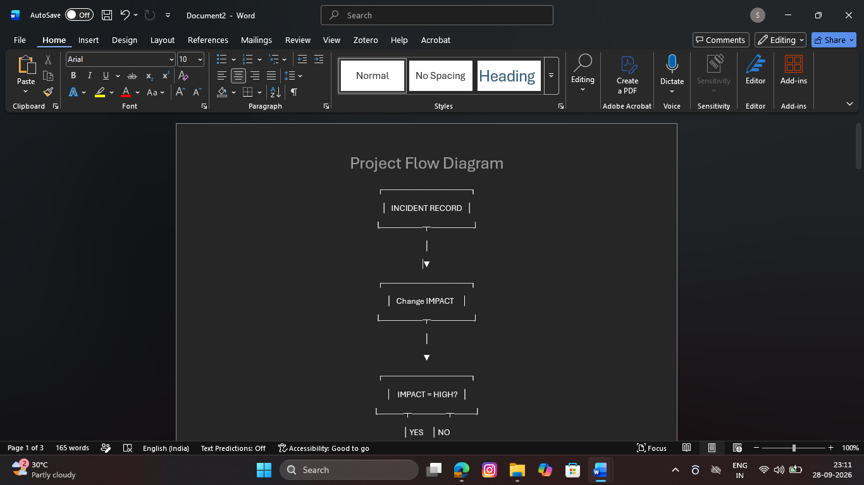

6. ServiceNow Implementation
The project was implemented on the Incident table in ServiceNow using UI Policies, UI Policy Actions, and Client Scripts. These controls were configured to dynamically manage Incident form behavior and improve data integrity.

6.1 High Impact Control — UI Policy
A UI Policy named High Impact Control was created for the Incident table.
Configuration:
Property | Configuration
Name | High Impact Control
Table | Incident
Active | True
Condition | Impact is 1 – High
Mandatory field | Assignment Group
Reverse if false | True
When the Impact of an Incident is set to High, the UI Policy applies the required field behavior. When the condition becomes false, the reverse behavior is applied.
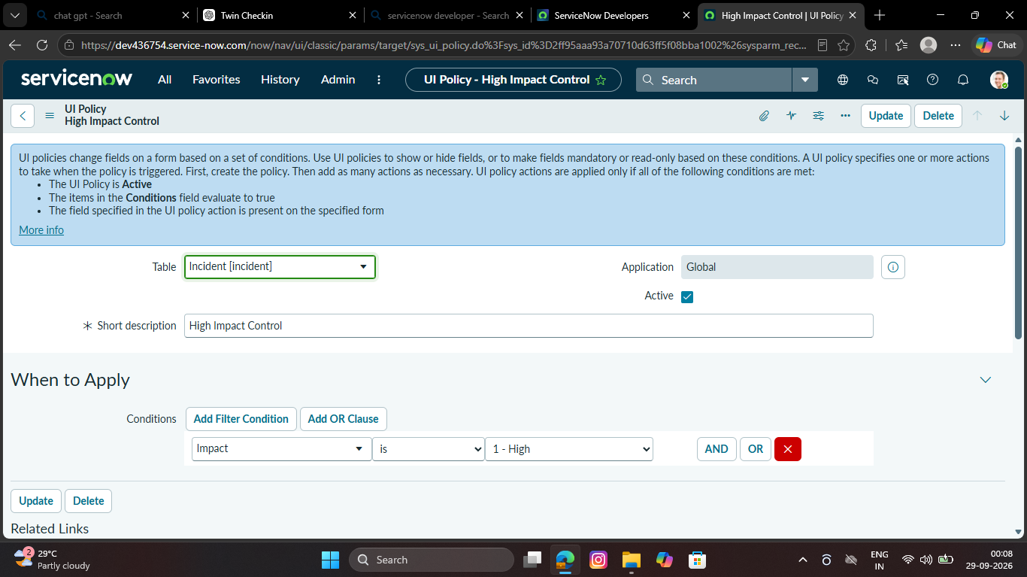
6.2 UI Policy Action — Urgency
A UI Policy Action was added to the High Impact Control policy for the Urgency field.
Configuration:
Property | Configuration
UI Policy | High Impact Control
Field | Urgency
Read-only | True
Visible | Unchanged
Therefore, when the High Impact condition is active, the Urgency field becomes read-only.
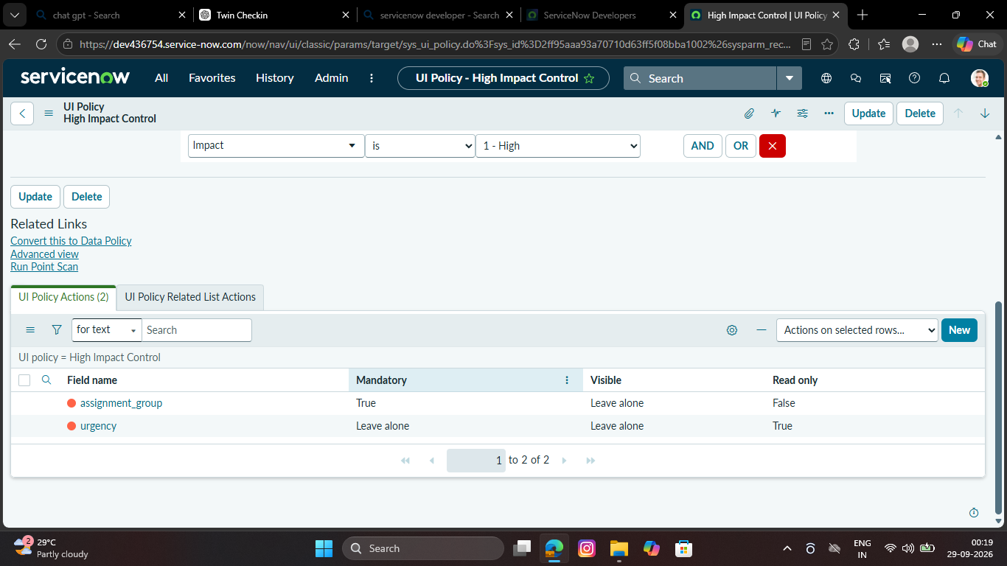
6.3 onChange Client Script
The Client Script Auto set urgency for high impact was created with:
Property | Configuration
Name | Auto set urgency for high impact
Table | Incident
Type | onChange
Field | Impact
Active | True
When the Impact value changes to High (1), the script automatically sets Urgency to High (1) and displays an informational message to the user.
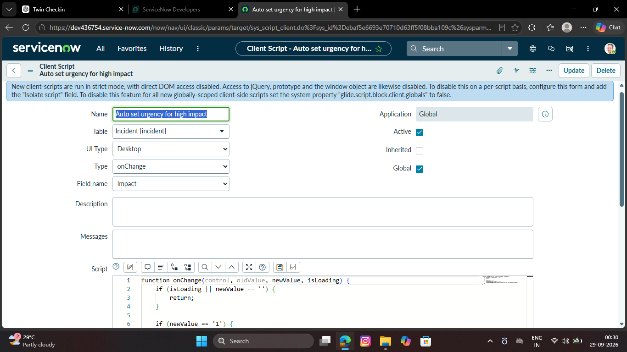
6.4 onSubmit Client Script
The Client Script Prevent save if Assigned To missing was created to validate the Incident before submission.
The script checks whether:
- Impact is High.
- Assigned To is empty.
If both conditions are true, an error message is displayed and submission is prevented. Otherwise, the Incident can be submitted.
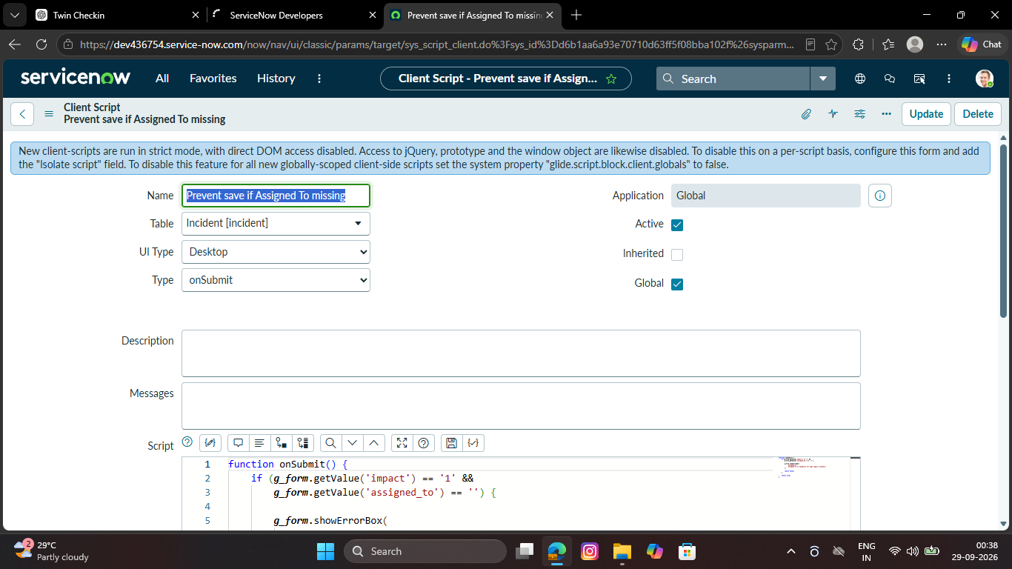Documentation note: The official project instructions use Assignment Group for the Task 1 UI Policy requirement but refer to Assigned To for the onSubmit validation and testing. We are preserving that terminology rather than silently changing the source requirement.

6.5 onCellEdit Client Script
The Client Script Prevent state change via list edit was created for the State field.
Property | Configuration
Name | Prevent state change via list edit
Table | Incident
Type | onCellEdit
Field | State
Active | True
When a user attempts to change the State directly from the Incident list, an alert message is displayed and the change is blocked. Users must open the Incident form to make the State update.
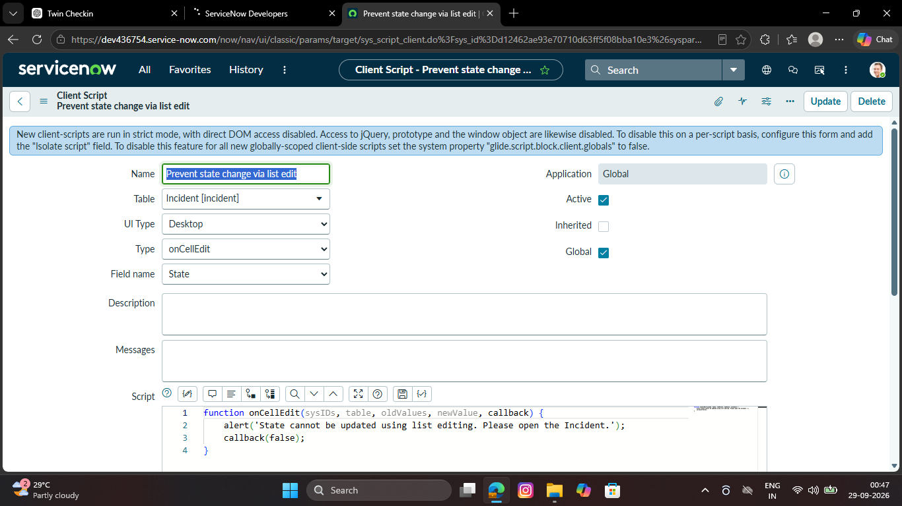

7. Testing and Results
After completing the ServiceNow configuration, the implemented UI Policies and Client Scripts were tested using different Incident scenarios. The purpose of testing was to verify that the configured controls behaved correctly under both normal and restricted conditions.
7.1 Test Case 1 — Mandatory Enforcement
Objective:
To verify that an Incident with Impact = High cannot be submitted when the required assignment information is missing.
Test Procedure:
- Open a new Incident.
- Set Impact to High.
- Leave Assigned To empty.
- Click Submit.
Expected Result:
The Incident should not be saved and an appropriate validation error should be displayed.
Actual Result:
The validation was triggered and the Incident submission was prevented.
Status: ✅ PASSED
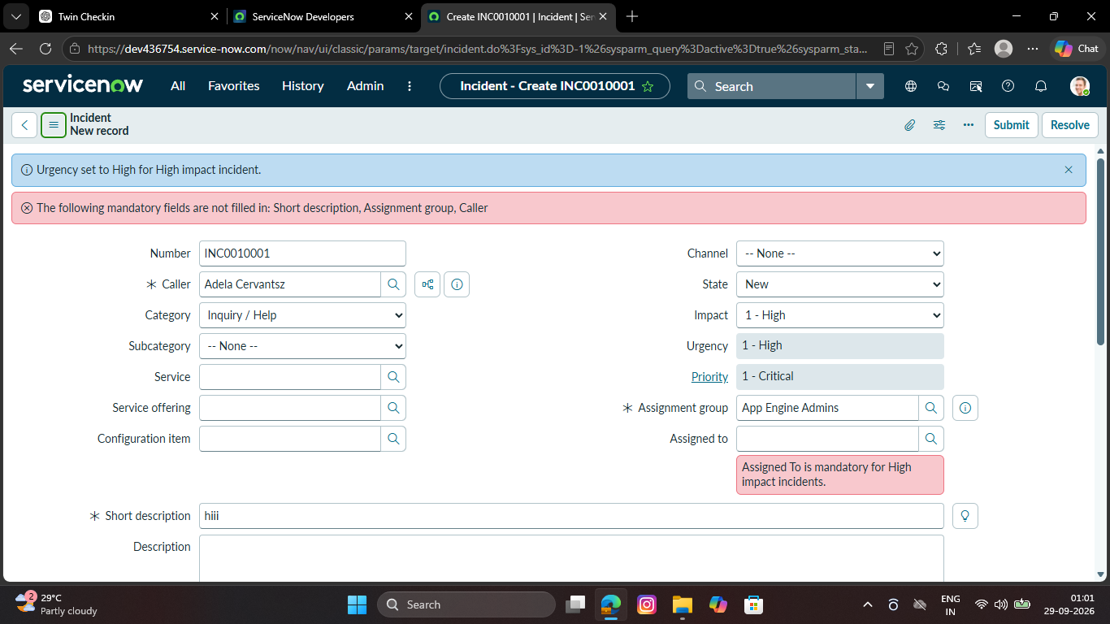
7.2 Test Case 2 — Successful Save
Objective:
To verify that a High Impact Incident can be successfully saved when the required assignment information is provided.
Test Procedure:
- Create or open an Incident.
- Set Impact to High.
- Provide the required assignment information.
- Verify the automatic Urgency behavior.
- Submit the Incident.
Expected Result:
The Incident should save successfully, with the configured Urgency and field restrictions applied.
Actual Result:
The Incident was successfully saved and the configured behaviors worked correctly.
Status: ✅ PASSED
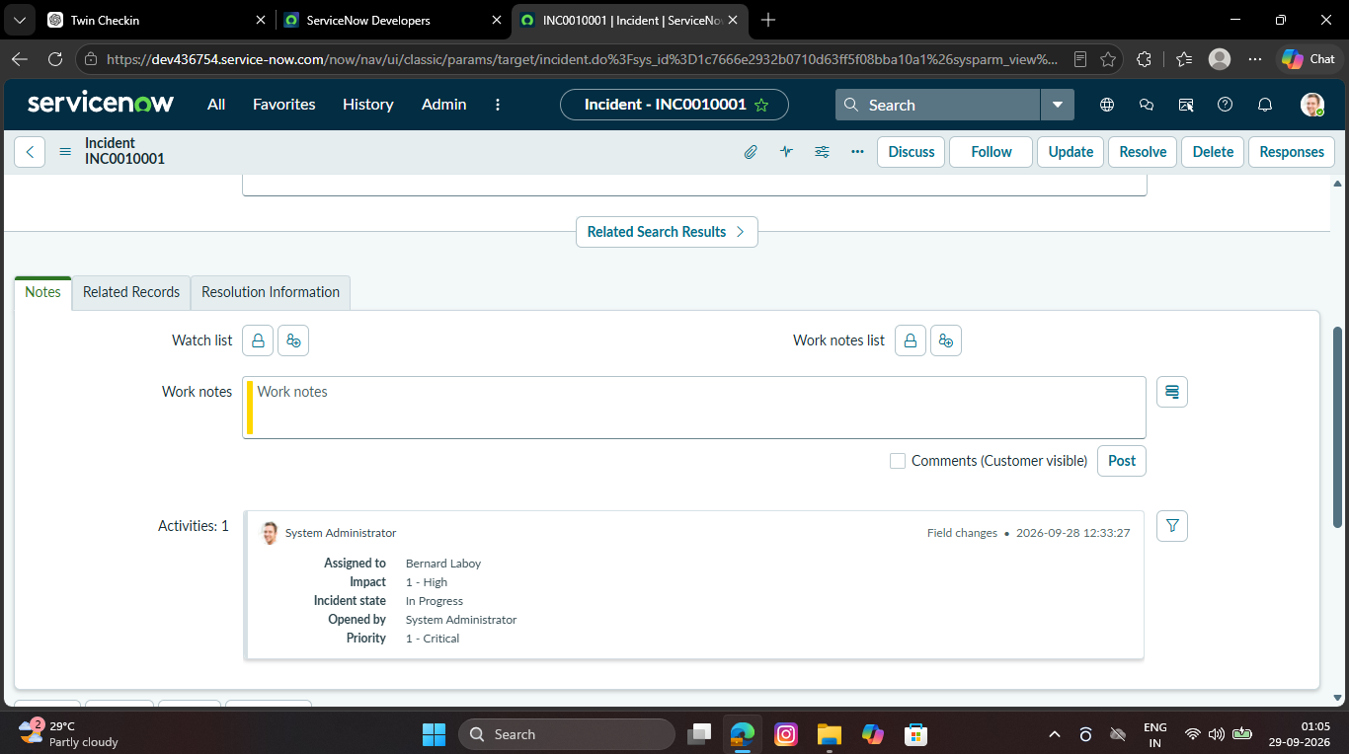
7.3 Test Case 3 — Reverse Condition
Objective:
To verify that the UI Policy reverses its behavior when the High Impact condition is no longer true.
Test Procedure:
- Open an existing High Impact Incident.
- Change Impact from High to Medium.
- Check the assignment field behavior.
- Check the Urgency field behavior.
- Save the Incident.
Expected Result:
The mandatory requirement should be removed and the appropriate field behavior should revert.
Actual Result:
The reverse condition worked correctly and the Incident was saved successfully.
Status: ✅ PASSED
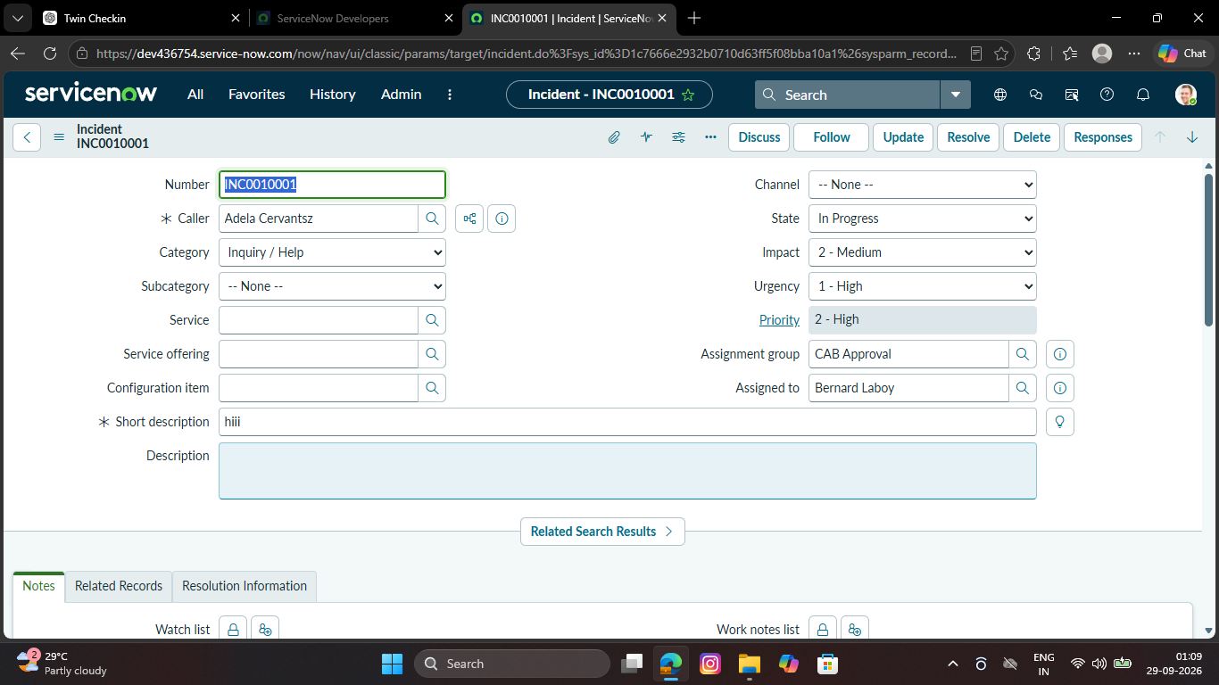The official instructions specifically require verification of this reverse behavior.

7.4 Test Case 4 — List Edit Blocking
Objective:
To verify that the State field cannot be changed directly through Incident list editing.
Test Procedure:
- Open the Incident list.
- Locate an Incident.
- Double-click the State field.
- Attempt to change its value.
Expected Result:
An alert should appear and the State change should be blocked.
Actual Result:
The alert was displayed and the State value remained unchanged.
Status: ✅ PASSED
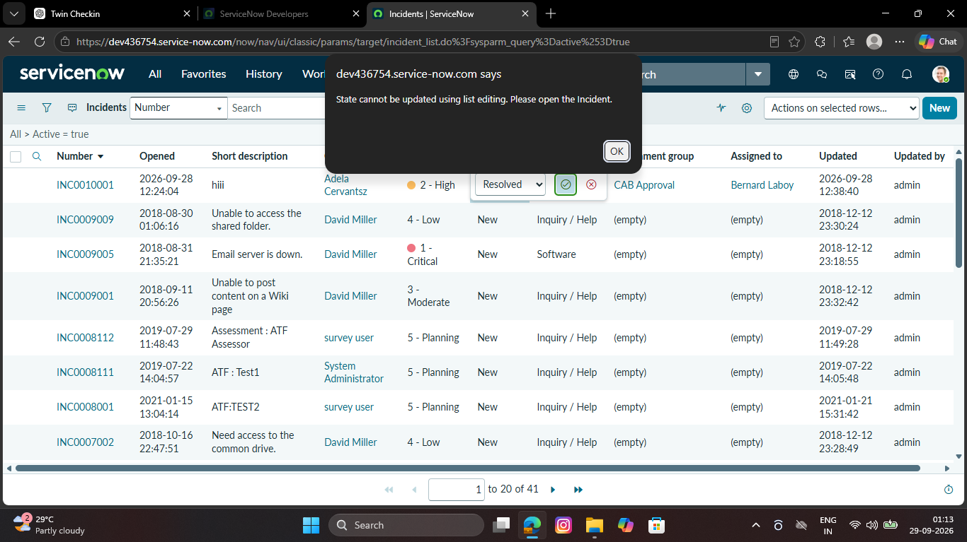
7.5 Test Case 5 — Form-Based State Update
Objective:
To verify that State can still be changed through the normal Incident form.
Test Procedure:
- Open the same Incident from the list.
- Change the State from the Incident form.
- Click Update.
Expected Result:
The State change should be accepted and the Incident should save successfully.
Actual Result:
The State was successfully updated through the Incident form.
Status: ✅ PASSED
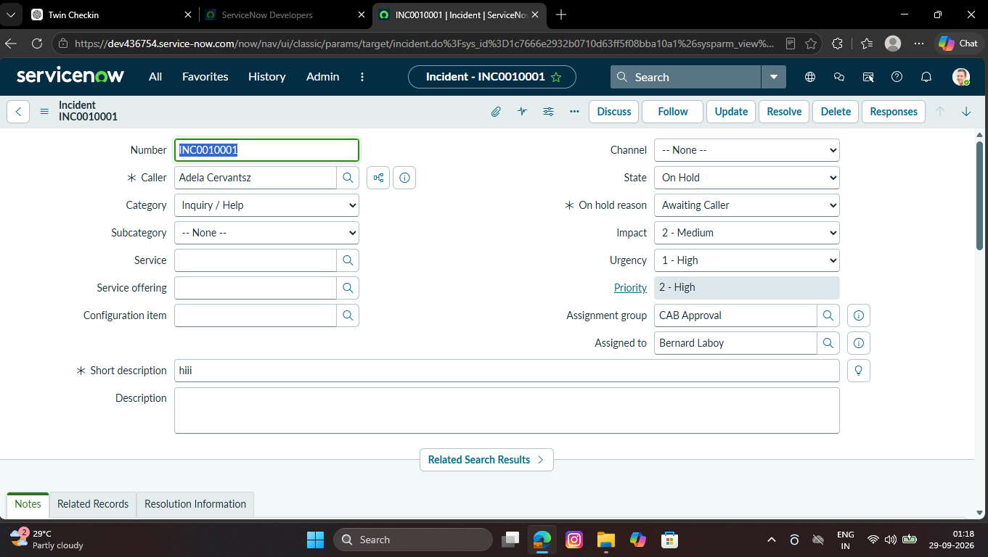The official testing instructions distinguish this normal form-based update from the blocked list-edit operation.

📊 7.6 Testing Summary
Test Case | Test Description | Result
Test 1 | Mandatory Enforcement | ✅ PASSED
Test 2 | Successful Save | ✅ PASSED
Test 3 | Reverse Condition | ✅ PASSED
Test 4 | List Edit Blocking | ✅ PASSED
Test 5 | Form-Based State Update | ✅ PASSED
Overall Testing Result
5 / 5 test cases passed successfully.
The testing confirmed that the configured UI Policy and Client Scripts performed the required validation, dynamic field control, automatic update, and list-edit restriction behaviors.

8. Benefits of the Project
The implementation of UI Policies and Client Scripts provides several benefits for Incident Management:
- Improved Data Accuracy: Helps ensure that required information is provided before an Incident is submitted.
- Consistent Data Entry: Applies defined rules consistently across Incident records.
- Dynamic Form Behavior: Fields can change their behavior based on Incident conditions.
- Automatic Value Updates: Urgency can be automatically set when Impact is changed to High.
- Improved Validation: Client-side validation prevents submission when required conditions are not satisfied.
- Controlled List Editing: Prevents State from being changed through list editing while allowing updates through the normal Incident form.
- Better Incident Management: These controls help improve the quality and consistency of Incident records.
These benefits align with the project's stated purpose of using client-side controls to improve Incident data integrity and service quality.

9. Conclusion
The “Implement Client Script & UI Policy (Incident)” project successfully demonstrated the use of ServiceNow UI Policies, UI Policy Actions, and Client Scripts to control and validate Incident records.
The implemented configuration provides mandatory-field enforcement, automatic Urgency updates, dynamic field behavior, submission validation, and restrictions on State changes through list editing.
Testing was performed using five different scenarios, and all five test cases passed successfully. The project therefore demonstrates how lightweight client-side controls can be used to improve data consistency and enforce appropriate behavior when working with Incident records.

10. Project Evidence
Add the following screenshots to the documentation:
ServiceNow Implementation Evidence
- Phase-5-Step-1-High-Impact-UI-Policy.png
- Phase-5-Step-2-UI-Policy-Actions.png
- Phase-5-Step-3-onChange-Client-Script.png
- Phase-5-Step-4-onSubmit-Client-Script.png
- Phase-5-Step-5-onCellEdit-Client-Script.png
Testing Evidence
6. Test-1-Mandatory-Enforcement.png
7. Test-2-Successful-Save.png
8. Test-3-Reverse-Condition.png
9. Test-4-List-Edit-Blocking.png
10. Test-5-Form-Based-State-Update.png

